Archival Offer Form
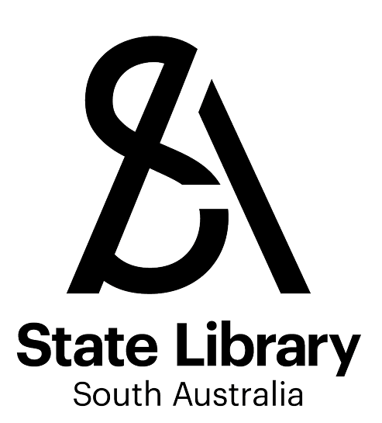
The Library welcomes offers of unpublished material and non-government records, including personal papers, pictorial and other unpublished materials which documents the diverse lives, activities, and achievements of South Australian people, as well as the places, events and ideas that shape our society. All offers will be assessed in line with the Library’s Collections Policy.

Please send this form to the address below or the Archival Collections Team at the email address at SLSA.ArchivalCollections@sa.gov.au

Mail:
Archival Collections Team
State Library of South Australia
North Terrace Adelaide SA 5000

CONTACT INFORMATION
Contact name
Email address
Phone number
Address

State Postcode

DETAILS OF YOUR OFFER
Description of material
Briefly describe the item or collection you wish to offer. Why was the material created, what people, events, places, subjects are documented?
Does your offer contain First Nations material?
YES ☐ NO ☐ NOT SURE ☐

Significance
Please tell us why this material is significant to the State Library.
Provenance of the collection
Briefly describe your relationship to the material (e.g. creator, collector, executor) and how you acquired the collection.
Quantity/size of the collection
Indicate the extent of the material (e.g. 1 painting, 4 wine boxes, 4 drawer filing cabinet, 12 digital photographs, etc).

Where is the collection?
Please describe how the records are housed - eg archival boxes, other boxes, filing cabinets, open shelving.
Physical condition
Please indicate the condition of the material - eg clean, dry, free of dust/pests/mould.
Is your offer a donation?
YES ☐ NO ☐ NOT SURE ☐
Any additional information
Please provide any additional information that may be relevant or let us know if you have any questions.

